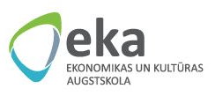 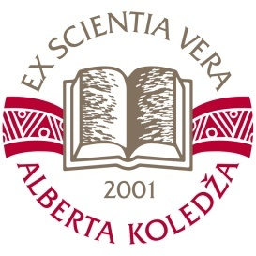

**The University College of Economics and Culture**

**in cooperation with Alberta College**

**Invites you to the International scientific practical conference for students**

**“Students’ Research Activity: Theory and Practice’2015”**

**18 – 19 March 2015, Riga, Latvia**

**Venue:**

***18.03.2015*** at 12:30 **–** The University College of Economics and Culture, 1/5 Lomonosova Street, Room 102

***19.03.2015*** at 11:00 – Alberta College, 22 Skolas Street

The **aim** of the conference is to introduce results of students' research activity on actual theoretical and practical questions, related to knowledge gained through study process and usage of this knowledge in acquiring research skills.

**Conference tracks:**

**Track 1.** Economics (Economics, Finances, Business Competitiveness, Accountancy, Taxes etc.);

**Track 2.** Management (Personnel Management, Business Management, Culture Management, Entrepreneurship Planning and Organising, Innovative Entrepreneurship, Innovative Business Management, Leadership etc.);

**Track 3.** Translation and Interpreting (Business Foreign Languages, Creative Methods in Translation and Interpreting etc.);

**Track 4.** Public Relations and Marketing (PR, Marketing Communication, Marketing, Consumer Behaviour in the Market etc.);

**Track 5.** Usage of ICT in Solving Business Problems (Computer Programs Development, Computer Programs for Business Needs, ICT External Services Opportunities, Internal Network Administration, Programming etc.);

**Track 6.** Business Legal Provision (Legal Documents Preparation, Conclusion of a Deal etc.);

**Track 7.** Creative Projects (Presentation of Students’ Creative Projects – Promotional Video Clips, Events’ Presentations, Movie Trailers etc.).

College, university college, academy and university students of all levels (1st level, Bachelor, Master, Doctoral) are kindly invited to participate in the conference!

The official languages of the conference – Latvian, Russian and English.

**Registration** **and Submission of Abstracts**: <http://conference.augstskola.lv/>

Registration deadline – 15 March 2015.

Conference Guidelines are available online - <http://www.augstskola.lv/content.php?parent=90&lng=eng>